Department of Computer Science & Engineering

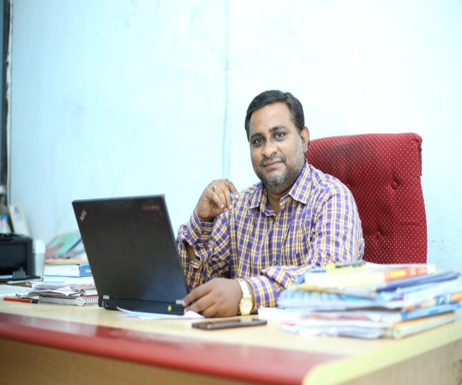
Mr ME. Chakravarty, BTech, MTech, (PhD)
HOD & Associate Professor
Qualified in APSET 2019

Mr Chakravarty is a renowned person in the area of Computer Science & Engineering having over 15 years of experience in teaching, held different positions like Assistant Professor, Associate Professor, In-Charge HOD at various reputed engineering colleges and now as Head and Associate Professor in GVR&S College of Engineering and Technology.
Mr Chakravarty is presently pursuing PhD in the area of Machine Learning and Deep Learning, Annamalai University, Tamilnadu in 2018-2022 academic year batch. He completed his Master’s Degree in Acharya Nagarjuna University and Bachelor’s Degree in JNTU.
Broad Area of Research:
- Machine Learning
- Deep Learning
- Data Mining and Data Warehousing

Honors:
- Qualified Assistant Professor in Andhra Pradesh State Eligibility Test (APSET) – 2019

Academic Achievements: Subjects Taught:
UGC CARE | 1  - Database Management Systems  - Compiler Design  - Programming in C  - OOP using C++  - Java Programming  - Data structures  - Web Technologies  - Unix programming  - Data warehousing and Mining  - Formal language and Automata  - Artificial Intelligence  - Machine Learning
UGC | 1
Scopus unpaid | 2
International Conferences | 11
Seminars organized/attended | 3/2
Workshops organized/attended | 1/4
FDP’s organized/attended | 4/60
NPTEL | 2
STTP attended | 6
Webinars organized/attended | 5/81

